Week In Review - August 31 - September 4, 2001
Alex Shvartsman

GRAND PRIX-LONDON
Kai Budde set a number of records last season - but he is far from resting on his laurels. Budde set yet another record at the very first major tournament he gets to compete in this season. Having won Grand Prix-London, Budde is now the only player to have won four Grand Prix. Since he also holds the record for winning the most individual Pro Tours, and most Player of the Year titles, this makes him the most successful competitor in the history of the game.

Kai has been winning everything - is the Invitational next?
Budde won in style, using an archetype that many pros wrote off as no longer viable. His Domain deck was good enough to win him the title. Pierre Malherbaud also made Top 8 with a Domain variant. His deck used four Destructive Flow, metagaming against the field where most decks use 10+ non-basic lands. Other notable pro players in the Top 8 included Warren Marsh (u-g tempo), and Antoine Ruel (r-b Aggro). Sigurd Eskeland missed Top 8 on tiebreakers with a u-b-w discard deck he used to re-qualify for the Pro Tour a few weeks ago.
David Williams was also playing Eskeland's deck, and started out with a perfect 8-0 record after Day 1. Day 2 could not have been worse for him though - he finished it with a 1-5 record, missing out on the money. What's more, at the end of the day, he was notified that the DCI chose to suspend him for a period of one year, effective immediately. Williams will not get a chance to compete at Pro Tour-New York and will have to miss out on the entire season. This penalty comes from an incident that caused Williams to be disqualified from the World Championship last month.
Overall, the tournament was a resounding success. Unlike GP-Manchester, this Grand Prix was far from small, gathering 650 players. Since all those participating in the Grand Prix had to pay a $30 entry fee to Gen Con UK, the Grand Prix itself as well as all the Constructed side events were free to enter. Limited events were quite inexpensive as well - you could use your own booster packs and pay one pound ($1.50) to sign up for any draft, or get some free drafts in if you used to be a Legend level DCI member. Carl Crook, Kieren Chase and Paul Barclay represented DCI, with Barclay in charge of the Sideboard coverage.

GRAND PRIX-SINGAPORE
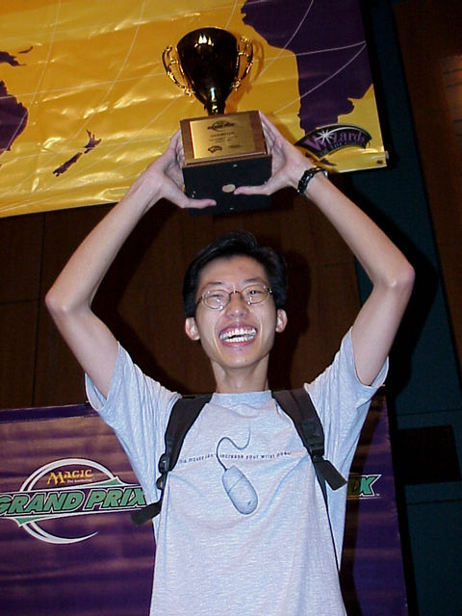
A smaller Grand Prix was held the same weekend in Singapore. I don't know very much about it, as I attended the one in London, but I do know that it was a smaller field than that in London, with few pros arriving from outside of the region. Of the Japanese competitors who did make the trip, most notable was Itaru Ishida who finished in the Top 16 with a Questing Phelddagrif deck (strangely, Ishida did not play the deck that won him the mammoth GP-Kobe). Singapore's top pro Albertus Law, who defeated teammate Kelvin Hoon in the finals, won the tournament. Law played Trenches control. Hoon also played a r-u-w deck with Goblin Trenches, but his version was a lot more aggressive, featuring 16 creatures and only a single copy of this enchantment that seems to be defining the format.

COMING UP: TEAM PRO TOUR-NEW YORK
Pro Tour is back in New York, and back in its famous Madison Square Garden. With DCI rating invitations extending to any team at 1700 or better, this is expected to be the largest Pro Tour in history. It is possible that over 200 teams will attend. Team Rochester Draft is possibly the most skill-intensive format in the game, but to get to play it, players will have to battle their way through at least seven rounds of sealed deck play. To level the field a bit, players will get to build at least three different sets of decks - so no team should be likely to make it on the strength of opening better cards alone.

MAGIC TRIVIA
Last week's Question:
Where did the Invitational Rade won take place?
Hong Kong. Since its inception, the Invitational has always been set at very exotic locations. This year will be no different, as pro players will travel to South Africa in October.
New Question:
This excellent question is brought to you courtesy of Andrew Levine:
How is it possible to attack your opponent BEFORE the first main phase of the turn? This isn't a trick question; there really is a combination of cards that lets you attack before you've had a main phase.
Please do not e-mail me your answers. The correct answer will be posted in next week's column.

BAD PLAY OF THE WEEK
Reported by Eivind Nitter:
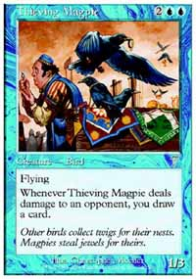
Nitter won the European Championship this year - but he did not play flawlessly. During the Swiss rounds, he was playing Counter Rebels against Federico Dato's monoblue deck. After sideboarding, Dato surprised him with a second turn Juntu Stakes - a card that shuts down many of Nitter's powerful rebel searchers, including Lin Sivvi. On his turn, Nitter summoned Meddling Mage. After some deliberation, he named "Thieving Magpie." Had Nitter spent a few more seconds thinking about it, he would have realized that Dato was not likely to keep Thieving Magpie in his main deck after he boarded in Juntu Stakes.
As always, please send good/bad plays, cool trivia questions, and other news to NEW ADDRESS: ashv80@hotmail.com.

